21st December 2024

Dear Residents of Aldbury,

On behalf of the Cast and Crew of Netflix comedy series now officially entitled “Man vs Baby”, we want to extend our deepest gratitude for welcoming us into your community and allowing us to use your beautiful location as a part of our project.
Your hospitality and support have made our time here not only productive but truly memorable.
We understand that having a film crew in your neighbourhood may have caused some disruptions, and we sincerely appreciate your patience and understanding throughout the process. Your cooperation has been invaluable in helping us bring our creative vision to life.
We were constantly inspired by the unique charm of your community and the kindness of its residents. Whether it was assisting us with logistics, offering a friendly smile, or simply sharing your space with us, your contributions played a critical role in the success of our production.
I am very much grateful to the Parish Council for letting us to film here and for helping us to do so respectfully and responsibly, and to all the householders, landowners and local businesses who have worked with us along the way.

Once again, thank you for your generosity and for being such gracious hosts. We will always cherish our time spent here and hope our project does justice to the beauty and spirit of Aldbury.

Warm regards,

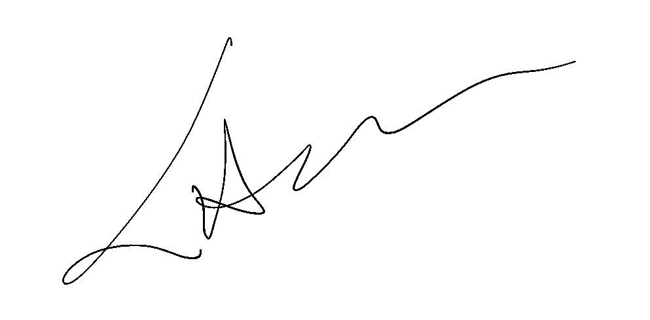

Piotr Litwinski
Location Manager
St James/ MVB Films

